Goodnites®
Best Fit and Protection Guarantee
US Version (Website)
Website Landing Page

Purchase any specially-marked Goodnites® products and if you are not completely satisfied, we’ll give you your money back.
Here’s how to get your money back:

Step 1: Download, print and complete by hand and in full the Money Bank Guarantee Form<hyperlink to download>

Step 2: Enclose all of the following in an envelope:
  - The original completed Money Back Guarantee Form.
  - The original store register receipt with a specially-marked Goodnites® product purchased between 1/1/24 – 12/31/24. Please circle product purchased and date on store receipt.
  - The original UPC Code from the package. UPC Code must match offer packaging.

Step 3: Mail all items listed above within 30 days of your purchase date with the proper postage to:
Goodnites® Money Back Guarantee
PO Box 705
North Branford, CT 06471

Valid Packs:
*post pictures of the eligible packs

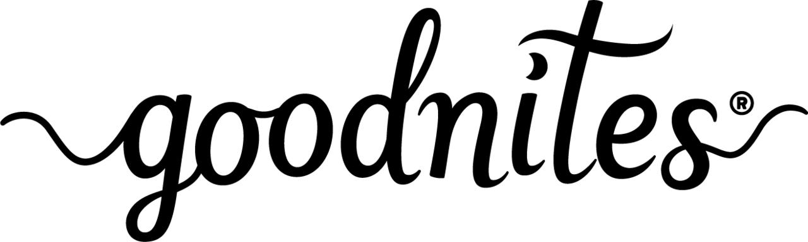
Best Fit and Protection Guarantee
Terms and Conditions
Complete Form for Download
US Version

We are committed to providing the best experience to our customers. Purchase any specially-marked Goodnites® products and if you are not completely satisfied, we’ll give you your money back.
Here’s how to get your money back:

Step 1: Complete by hand and in full this Money Bank Guarantee Form

Step 2: Enclose all of the following in an envelope:
- The original completed Money Bank Guarantee Form.
- The original store register receipt with a specially-marked Goodnites® product purchased between 1/1/24 – 12/31/24. Please circle product purchased and date on store receipt.
- The original UPC Code from the package. UPC Code must match offer packaging.

Step 3: Mail all items listed above within 30 days of your purchase date with the proper postage to:
Goodnites Money Back Guarantee
PO Box 705
North Branford, CT 06471

Subject to full Terms & Conditions below.
PLEASE PRINT CLEARLY:

Name______________________________________________________________________

Address____________________________________________________________________
(No mailing to PO Boxes)
City________________________________State____________Zip_____________________

Phone_________________________________Email________________________________

Goodnites® Product Purchased:
Girls____Boys____ Size________________Count_______________
(check one)
Price Paid_____________________________Date________________________________

Store_____________________________________________________________________

Reason for Request___________________________________________________________

The Goodnites® team closely monitors consumer comments and concerns about these products. As a result, a member of our team may reach out to you for additional information about your experience with this product.

Signature____________________________________________________________________

ONLINE ACCESS REQUIRED. Limit one rEimbursement per person/ PER HOUSEHOLD/per email address. LIMIT ONE PRODUCT PER REIMBURSEMENT. Only original mail-in Money Back Guarantee Form, store receipt and UPC (UPC Code must match offer packaging) will be accepted; no photocopies are allowed. Offer only valid for specially-marked Goodnites® packages with advertising concerning this offer. Purchase must be made in US. No responsibility is assumed for lost, late or misdirected mail or illegible and incomplete requests, or torn, separated or non-delivered mail or undelivered submissions. Fraud detection devices and validation processes may be used to determine eligibility. Any suspicious submissions, as determined by sponsor, are void. Use of multiple addresses or P.O. boxes to obtain additional refunds is fraud and may result in prosecution. No mailing to PO Boxes. Ineligible or incomplete requests will not be honored or returned. Purchase of eligible Goodnites® Products must be made between January 1, 2024 and December 31, 2024. Please circle product purchased and date on store receipt. All requests for reimbursement must be postmarked within 30 days of purchase and must be received no later than February 28, 2025. Offer good while supplies last. Offer valid only in the USA. Void where prohibited, taxed or restricted by law. No groups, clubs or organizations may participate in this offer or reproduce or distribute this form or any portion thereof to its members. Reimbursement not payable at retail location. Does not include sales tax. May not be used in conjunction with other offers. We will not honor incomplete submissions. Allow at least 8-10 weeks for delivery of reimbursement check. Reimbursement checks void if not used within 90 days of issuance and cannot be reissued. To check on status email: promotions@catalystnow.com

